[](https://2.bp.blogspot.com/-c91VRhTN_cI/WUdYqqYdKAI/AAAAAAABE-M/rJbxEZDVOT80d-6IyIs8yt6Ji6JKgoV6wCLcBGAs/s800/food_kome_pack_big.png)[](https://2.bp.blogspot.com/-BmWKPJdqgIk/UzoZ4lWrRBI/AAAAAAAAevY/g1YH3KaBBRI/s800/sugar.png)

**五大栄養素**

**五大栄養素**

[](https://4.bp.blogspot.com/-f7EwmF9LBcE/UaVVMUTx6YI/AAAAAAAAUBg/tXTDL4Qmw6A/s800/onigiri_character.png)

[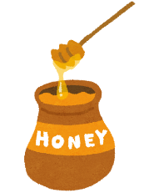](https://2.bp.blogspot.com/-jEkDzw5evvo/UV1JGvaQF1I/AAAAAAAAPTA/vJ6lBCm9i4Y/s1600/honey.png)[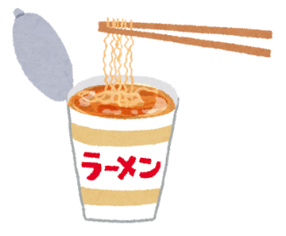](https://4.bp.blogspot.com/-gybqqjR5o9A/UZmCNjgj14I/AAAAAAAATd4/N2CK8u2Vbsk/s800/cup_noodle.png)

[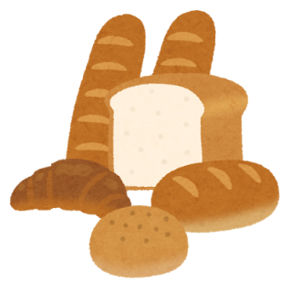](https://1.bp.blogspot.com/-GxVJ30JdhJw/XVKgLOn4P8I/AAAAAAABUH4/bnmmdSbR1yAU4S7aVKU3vlGIHUD7j7u5gCLcBGAs/s1600/pan_bread_set.png)

[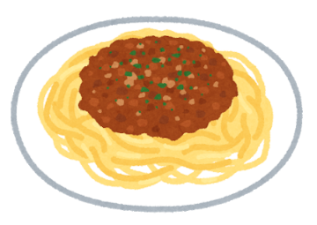](https://3.bp.blogspot.com/-EATHViUAKVI/W_UF9KEi82I/AAAAAAABQUE/9NkBAfsB9BgWgQOa4qBb_JQl9nvozV-JgCLcBGAs/s800/food_spaghetti_bolognese_meatsauce.png)[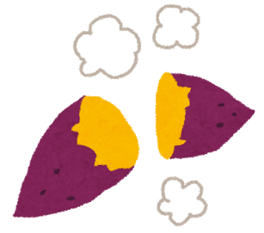](https://3.bp.blogspot.com/-f5Dws--OaQk/UgSMM28AN1I/AAAAAAAAW-k/FumMNn1Iw_o/s800/sweets_yakiimo.png)

**五大栄養素**

**五大栄養素**

[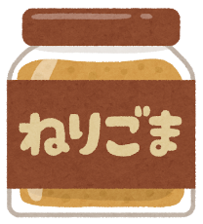](https://3.bp.blogspot.com/-TuCrpwVZy1Q/VxC3PZcpO3I/AAAAAAAA50o/hAS-zVvCL6ck03yGllxoLptHs3uU0G5VwCLcB/s800/cooking_nerigoma.png)

[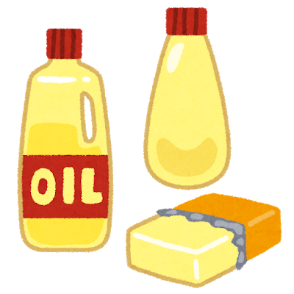](https://4.bp.blogspot.com/-gO1jNcYTEtw/Viio7_ozLHI/AAAAAAAAzrw/pgXJCAZSPBk/s800/food_eiyou2_shishitsu.png)

[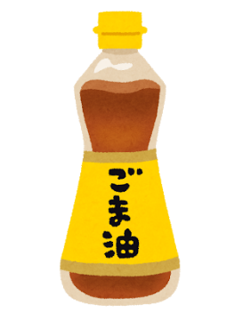](https://2.bp.blogspot.com/-hOUKvscjB7Y/U00KD6DhZlI/AAAAAAAAfNU/jinOePBDcZo/s800/food_gomaabura.png)

[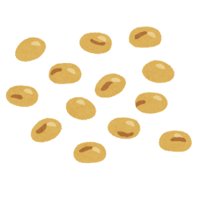](https://1.bp.blogspot.com/-IBoABCiNJpI/V6iId6esjGI/AAAAAAAA9CM/Ine7zoStc7keBxkJlcQ-0rjm7OriWwOUgCLcB/s800/vegetable_daizu.png)[](https://1.bp.blogspot.com/-aix6ReejJ3k/UVWMheWJAiI/AAAAAAAAPJM/eaTsdwhIJNU/s1600/kunsei_ham.png)

**五大栄養素**

**五大栄養素**

**たんぱく**

[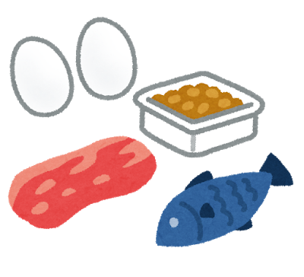](https://4.bp.blogspot.com/-g8q0o7Po2kQ/Viio8cJ9dCI/AAAAAAAAzr8/7xkwkxbGFiU/s800/food_eiyou3_tanpakushitsu.png)

[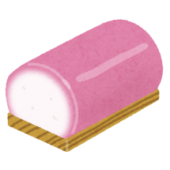](https://3.bp.blogspot.com/-9UEvjN861bM/VUIHPihv80I/AAAAAAAAtKE/HcB6vGGfJDg/s800/kamaboko_red.png)

[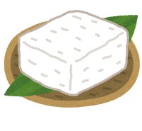](https://2.bp.blogspot.com/-dMEzDYX8OlU/VRUSDV5tf1I/AAAAAAAAslQ/6we0poh1YdM/s800/food_tofu_shimadoufu.png)

[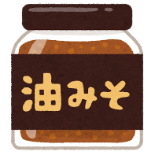](https://3.bp.blogspot.com/-8576L-H9oV0/WYAxucyGCqI/AAAAAAABFu4/d-magum8J4IuaPxcCfLYHbo2flqqnKFegCLcBGAs/s800/cooking_aburamiso.png)[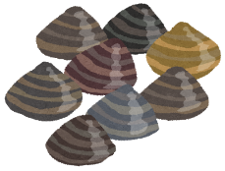](https://1.bp.blogspot.com/-YHgsdn_KguI/UP06KXqDstI/AAAAAAAAK4w/9UsrvN3Al94/s1600/asari.png)

**五大栄養素**

**五大栄養素**

[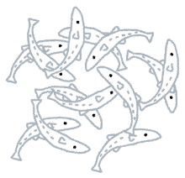](https://4.bp.blogspot.com/-W80yUxTFyvg/Uj_22xAv-UI/AAAAAAAAYDA/EOjRn0Rb5L8/s800/fish_shirasu.png)

[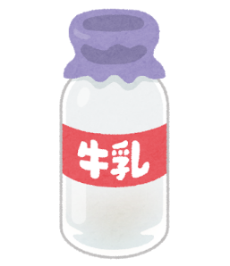](https://2.bp.blogspot.com/-6pRhgBs5tOE/VhHgLlEaaAI/AAAAAAAAy3w/DT9A2ryFsX0/s800/milk_bin.png)

[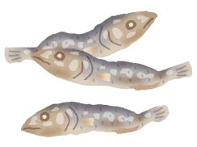](https://2.bp.blogspot.com/-y807qUst9c0/U-8GVBPDRlI/AAAAAAAAk3A/7Ns6D48gGR4/s800/food_niboshi.png)[](https://2.bp.blogspot.com/-QwgykKv9i_4/VkqUyFzyxZI/AAAAAAAA0k4/V3wBHyJ4LWI/s800/food_osechi_kobumaki.png)

[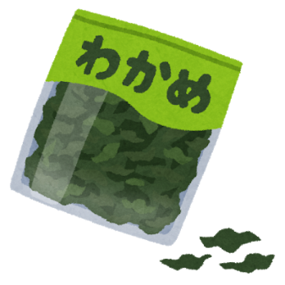](https://3.bp.blogspot.com/-liNouIXDnkE/VdLrsuZXxNI/AAAAAAAAwv4/mufbWGT-Gd8/s800/food_cut_wakame.png)

[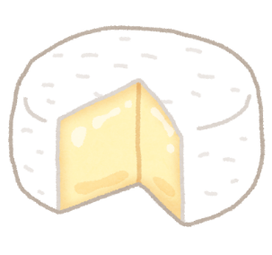](https://3.bp.blogspot.com/--gKUyA0SJAU/U7O8AtlXE2I/AAAAAAAAiYA/iwiyeNm95mo/s800/cheese_camembert.png)[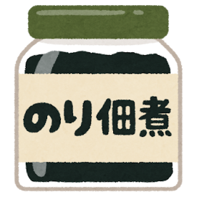](https://2.bp.blogspot.com/-i_F15L7GrIk/W1vhErWz63I/AAAAAAABNto/nxVPO97md-c9cEL9fGiCQhsaKkGcJB1vgCLcBGAs/s800/cooking_nori_tsukudani.png)

[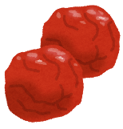](https://3.bp.blogspot.com/-AXuTbH14SdA/UdEeQY_yc1I/AAAAAAAAVrI/xCiAtlJHh8A/s510/food_umeboshi.png)[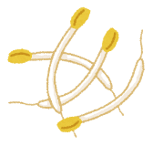](https://4.bp.blogspot.com/-O-Vbdf_zv38/Udy6pu2AkCI/AAAAAAAAWKY/_e_6cjFkiUw/s800/food_moyashi.png)[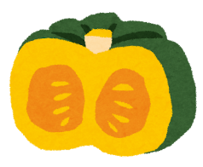](https://1.bp.blogspot.com/-Pvw0cjpU8PU/XUTi7aOOAGI/AAAAAAABT-E/_nodpClWjNUmUJf0pQnI7K2pqtyW1SORQCLcBGAs/s1600/kabocha.png)

**五大栄養素**

**五大栄養素**

**ビタミン**

**（色のこい野菜、その他の野菜、くだもの）**

[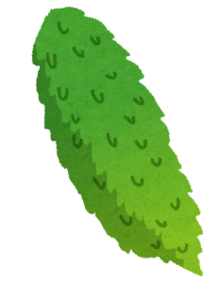](https://3.bp.blogspot.com/-Nt4dKawuffo/UkJM4H6t95I/AAAAAAAAYVA/2FzIfUH5CAo/s800/goya_bittergourd.png)[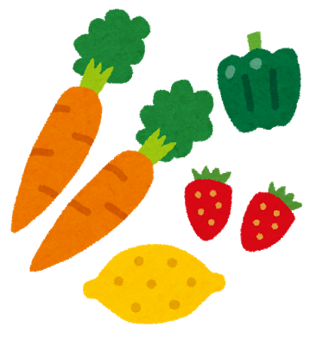](https://4.bp.blogspot.com/-ZWW8ak7aTvc/Viio8Y_PXiI/AAAAAAAAzsE/2RRPyZLXlg4/s800/food_eiyou4_vitamin.png)

[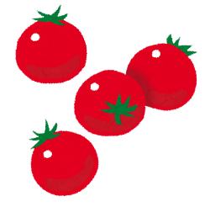](https://2.bp.blogspot.com/-0iZjlgNqN8k/Udy6pxR16uI/AAAAAAAAWKg/r_ngnFTJwD0/s800/food_puchitomato.png)

[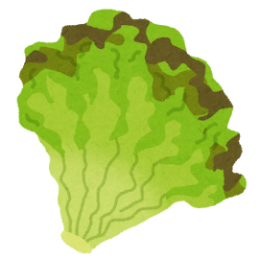](https://3.bp.blogspot.com/-G1ifYdmZovs/VGX8rlfei2I/AAAAAAAApK8/OdkKfCy4YJk/s800/vegetable_sunny_lettuce.png)[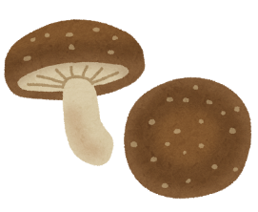](https://4.bp.blogspot.com/-BKS6qti9-Qo/UsZtLg5qjFI/AAAAAAAAcy4/VdPi_SZqTXM/s800/kinoko_shiitake.png)

**と**

**と**