[](https://3.bp.blogspot.com/-Y4QQQEsY728/URedBZmVRLI/AAAAAAAAMXE/lA1QzI97QAo/s1600/suimin_woman.png)

**五大栄養素**

**黄の食品**

**エネルギーになる**

[](https://1.bp.blogspot.com/-hw8U0g0kUhc/U8XkayZ6HPI/AAAAAAAAiwQ/oyxinfRFzR4/s800/benkyou_classroom.png)

[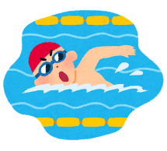](https://1.bp.blogspot.com/-__MLeBX71hY/V4Cdh37WPdI/AAAAAAAA8J0/WZVvY9XdK0QftUMacf2XI3DLyswuWMOVwCKgB/s800/sports_swimming_man.png)

**五大栄養素**

[](https://3.bp.blogspot.com/-Y4QQQEsY728/URedBZmVRLI/AAAAAAAAMXE/lA1QzI97QAo/s1600/suimin_woman.png)

**黄の食品**

**エネルギーになる**

[](https://1.bp.blogspot.com/-hw8U0g0kUhc/U8XkayZ6HPI/AAAAAAAAiwQ/oyxinfRFzR4/s800/benkyou_classroom.png)

[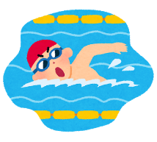](https://1.bp.blogspot.com/-__MLeBX71hY/V4Cdh37WPdI/AAAAAAAA8J0/WZVvY9XdK0QftUMacf2XI3DLyswuWMOVwCKgB/s800/sports_swimming_man.png)

[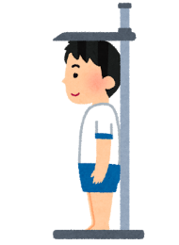](https://4.bp.blogspot.com/-rcQm_tpqx8U/VVGVeqVAImI/AAAAAAAAtmM/xvF9AChIJtE/s800/kenkoushindan01_shinchou.png)

**五大栄養素**

**たんぱく**

**赤の食品**

**体をつくる**

[](https://3.bp.blogspot.com/-KLsvZz5u3PQ/V1z9NhlbXjI/AAAAAAAA7QI/7DMtmzokbksgxLcqN3HlWLhVaOt7MSmsACLcB/s800/kinniku_hanasu.png)

[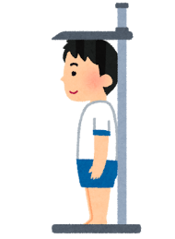](https://4.bp.blogspot.com/-rcQm_tpqx8U/VVGVeqVAImI/AAAAAAAAtmM/xvF9AChIJtE/s800/kenkoushindan01_shinchou.png)

**五大栄養素**

**赤の食品**

**体をつくる**

[](https://3.bp.blogspot.com/-KLsvZz5u3PQ/V1z9NhlbXjI/AAAAAAAA7QI/7DMtmzokbksgxLcqN3HlWLhVaOt7MSmsACLcB/s800/kinniku_hanasu.png)

**五大栄養素**

**ビタミン**

**（色のこい野菜、その他の野菜、くだもの）**

**緑の食品**

**体の調子を整える**



[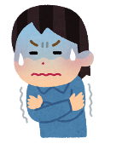](https://1.bp.blogspot.com/-ahRjsq2iSE0/XYhOZ6P4UuI/AAAAAAABVH0/gMyfkdP3oCsmucu8IQU0uyk04DuxMJAsACNcBGAsYHQ/s1600/sick_samuke_woman.png)

[](https://3.bp.blogspot.com/-elBvbkYp5Vs/WxTHe9KYfRI/AAAAAAABMcE/Yj9tGW8BpDYupYatW6U3tUM3M6WI6RnnQCLcBGAs/s800/vitamin_04_b2.png)

**黄・赤・緑の食品の体内でのおもな働き**

**黄・赤・緑の食品の体内でのおもな働き**